**FAMILY TREE**

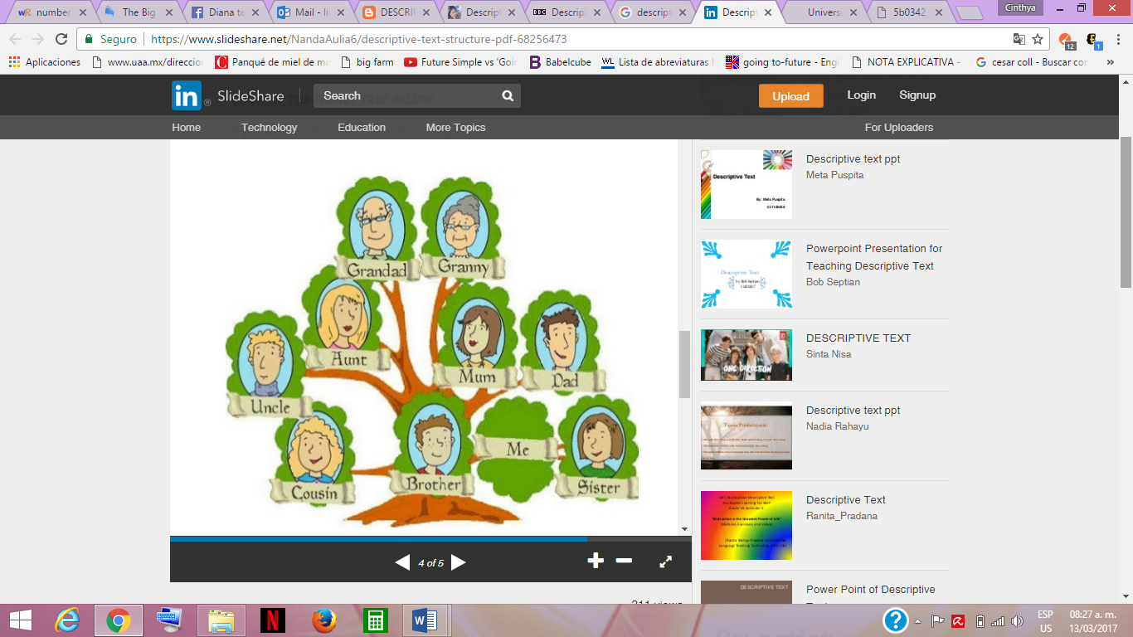

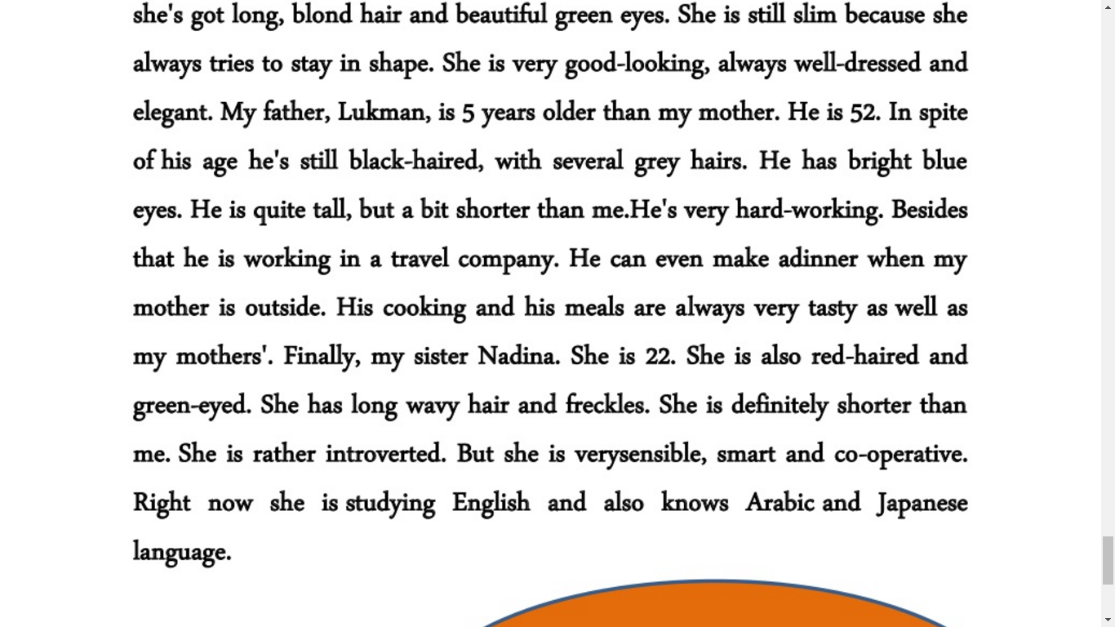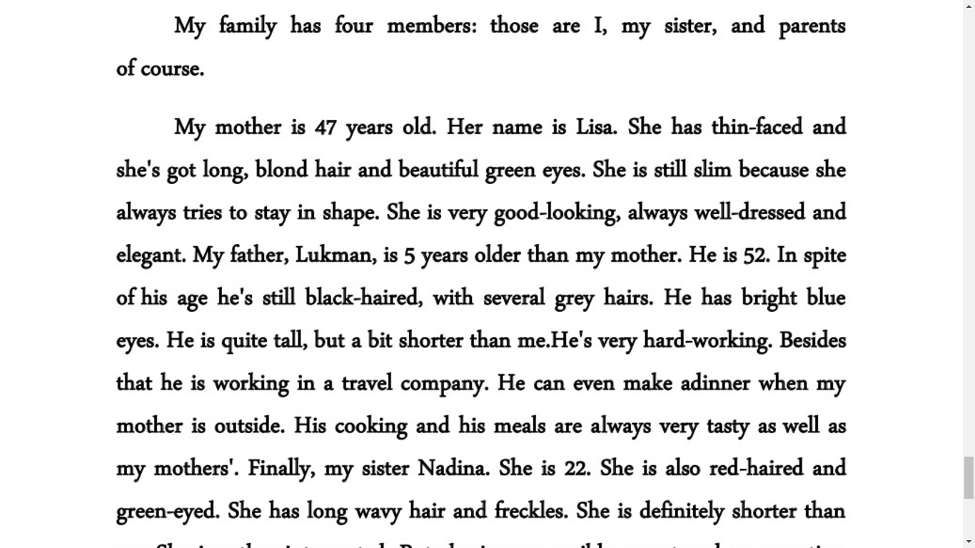

My family has five members: those are I, my sister, my brother, and parents of course.

My mother is 41 years old. Her name is Maria, she has thin-faced and she's got long dark hair and beautiful brown eyes. She is still slim because she always tries to stay in shape. She is very good-looking, always well-dressed and elegant. My father, Victor, is 6 years older than my mother. He is 47. he’s white-haired, with several grey hairs. He has brown eyes. He is short, shorter than me. He's very hard-working. Besides that, he is working in a food company. He makes dinner when my mother is outside. His cooking and his meals are always very tasty as well as my mothers'. My brother Martin is 24. He is also black-haired and brown-eyed. He has short hair. He is definitely taller than me. He is extroverted. He is strong, smart and co-operative. Right now He is not studying. Finally, my sister Daisy. She is 11. She is also black-haired and brown-eyed. She has long hair. She is definitely shorter than mesh is rather introverted. But she is very sensible and smart when she wants to. Right now she is studying Primary school.